**Project Organizer by Corey Crooks**

**An application to keep track of multiple projects in various states including what has been done, what needs to be done, and what is currently being worked on; meant for single-screen smartphone devices for those looking for a productivity-focused app that specializes in organization with minimal additions to keep the functionality focused.**

Prepared by

Corey Crooks

November 2, 2022

Storyboard . . . . . . . . . . . . . . . . . . . . . . . page 2

Design Specifications . . . . . . . . . . . . . . . page 7

**Storyboard**

Images created using Microsoft Visio

**The Home Screen:**

Users will start the app to the home screen. Here they can open an existing project if available, or create a new one. 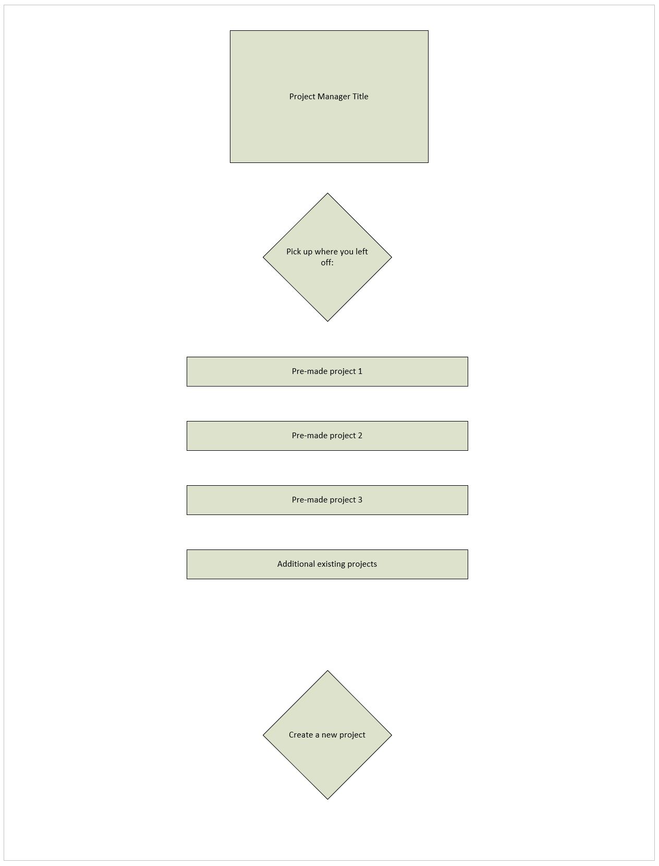

**The Project Overview:**

The user will navigate into their projects, and modify an existing project here.

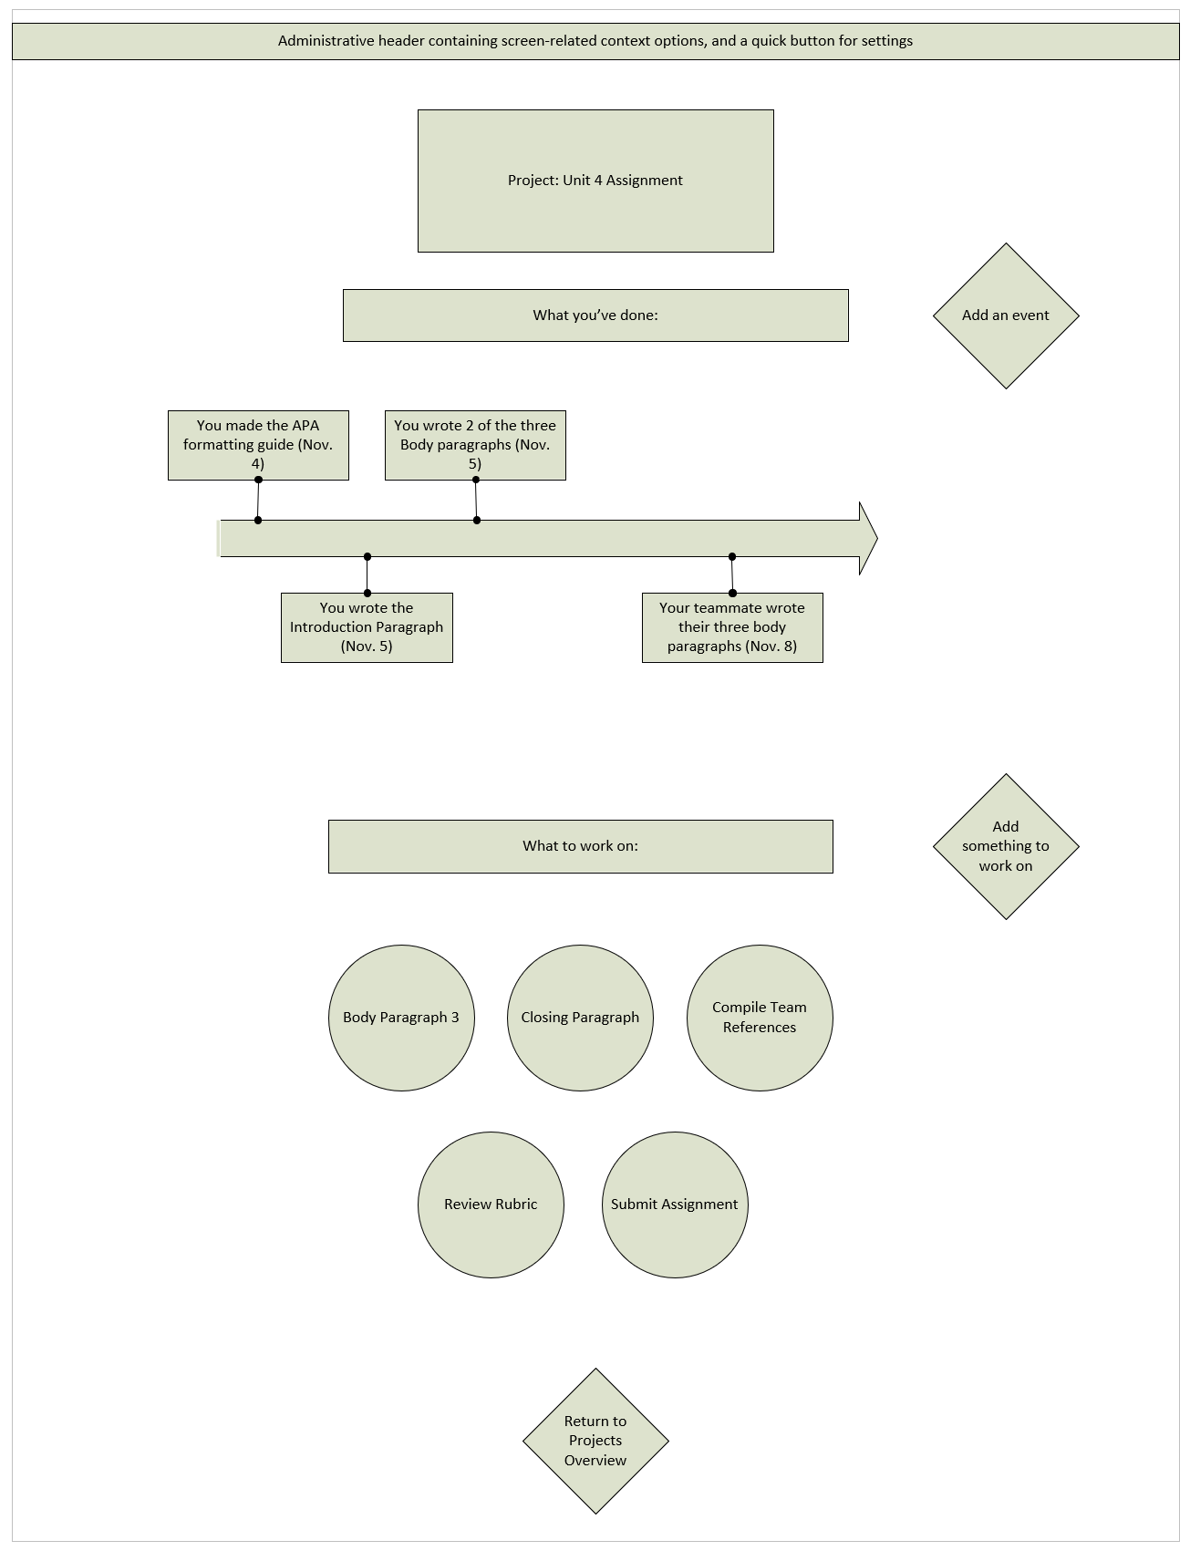

**Adding an Event:**

The user will be able to add an event that they’ve already done with this screen. 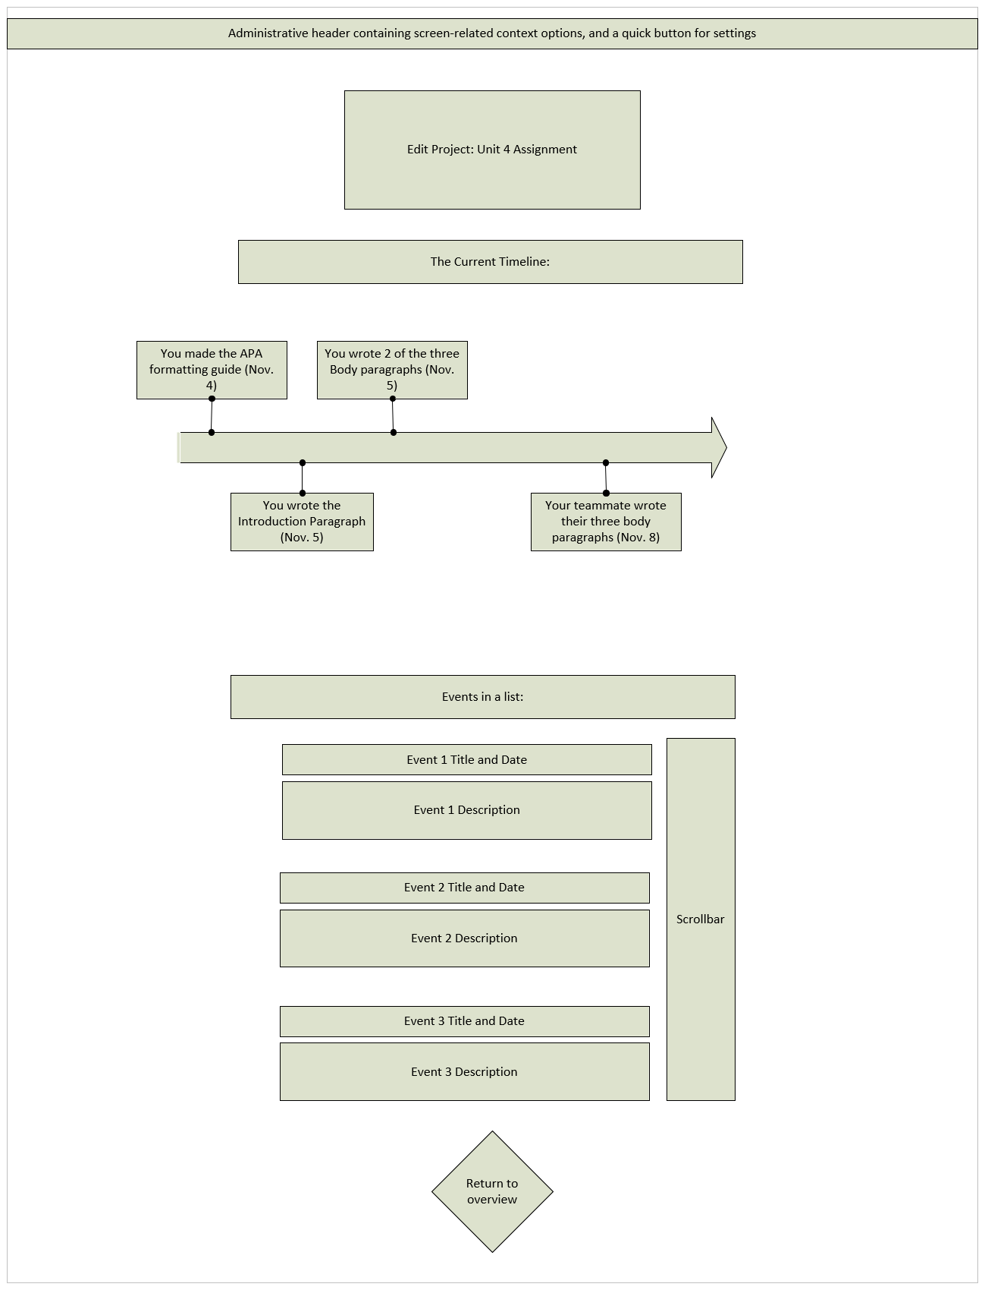

**Adding a Something to Work on:**

The user will be able to add an event that they’ve already done with this screen.

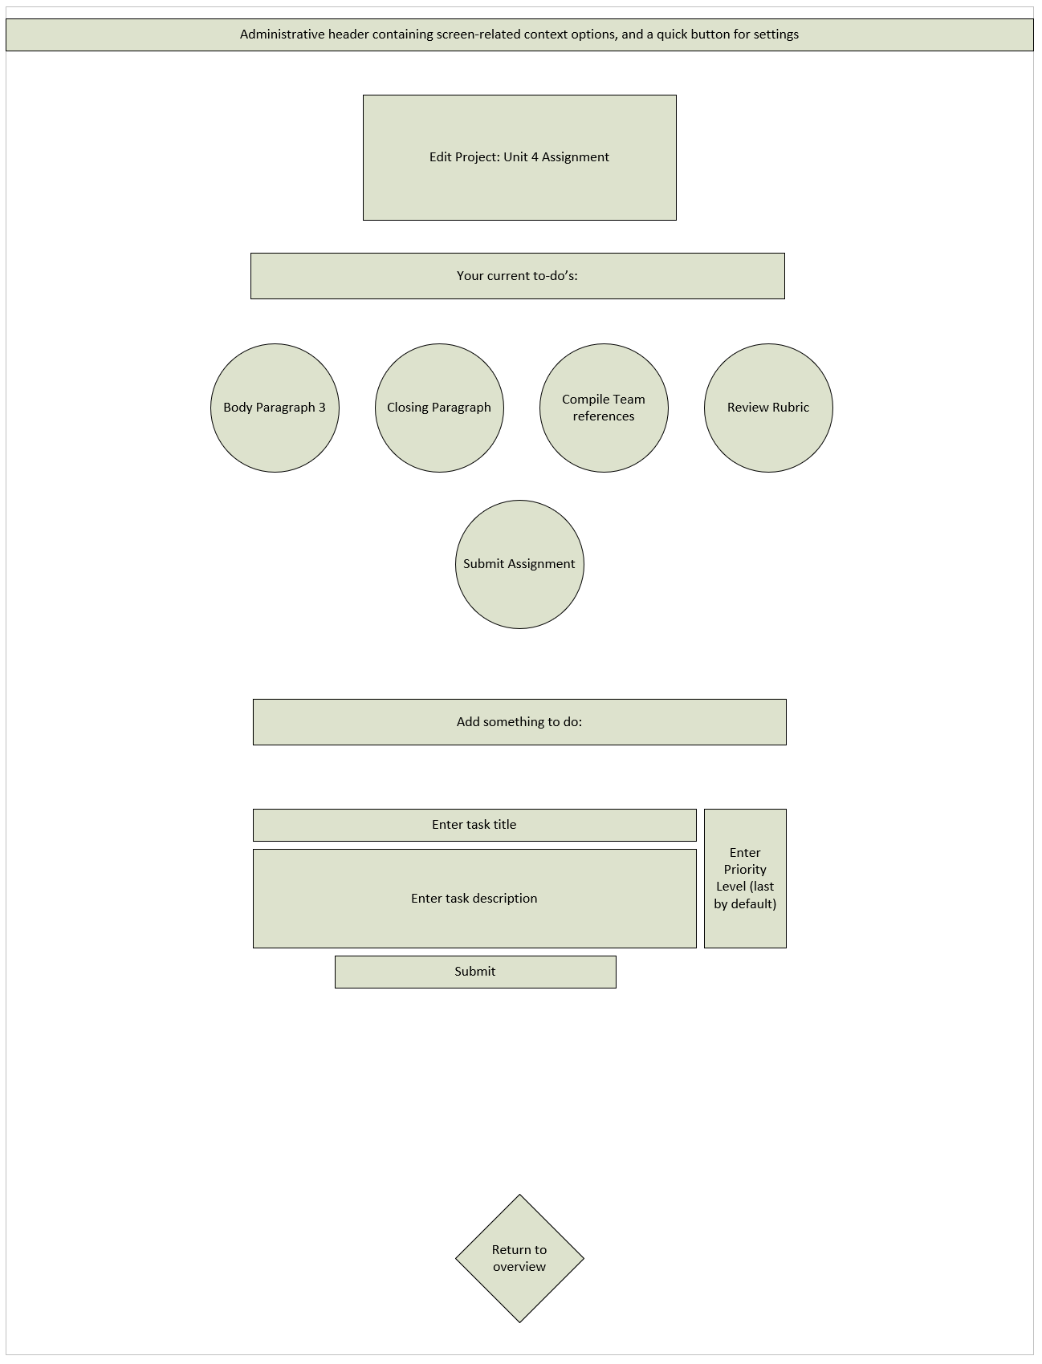

**User Settings:**

The user will be able to customize settings, and set preferences for the functionality of the app here.

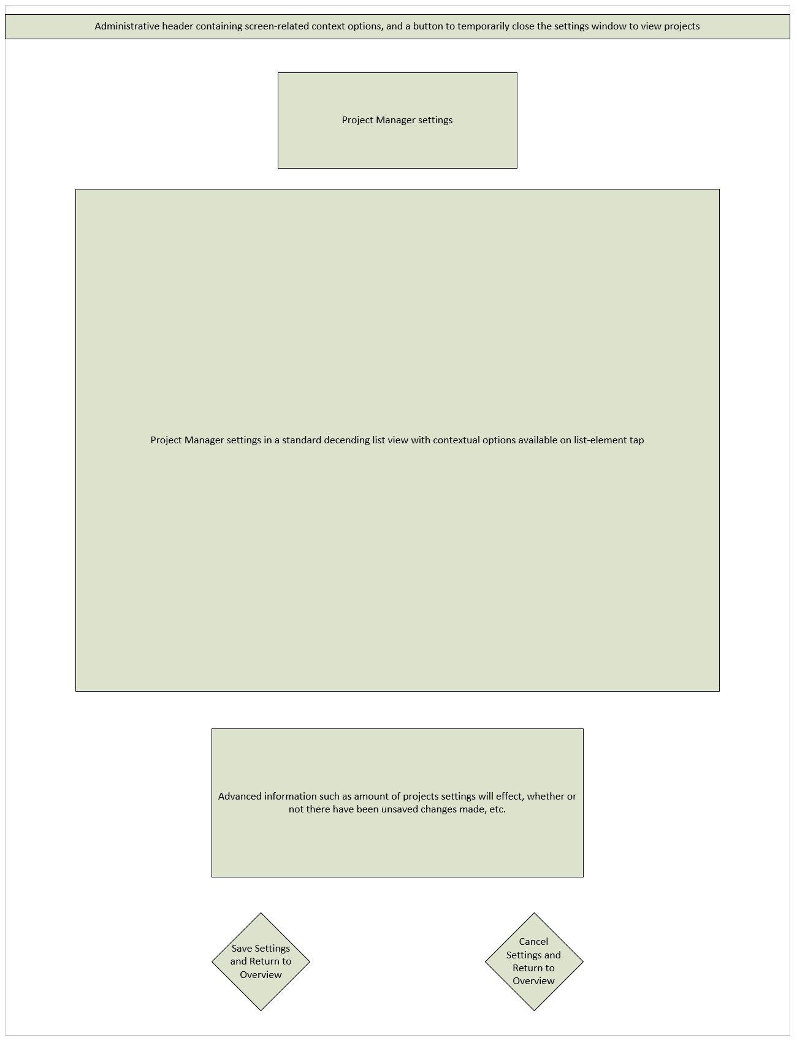

**Design Specifications**

|  |  |
| --- | --- |
| Number of screens | 1. Home/Startup  2. Project Overview  3. Add an Event  4. Add a To-Do  5. Settings |
| Fonts | * Arial Black (Titles) and Arial. * Font size, font family, font weight, and font kerning available to be changed in the settings. These options can be reset to default in the settings. |
| Colors | * Default Blue headers, and blue outlines on interactive areas like buttons. Text will be black by default while the background will be white by default. * Clours are available to be changed in the settings tab. The user may also assign a png or jpeg file to serve as the backgrounds for events and to-do’s either application-wide, or per project. This option can be reset to default in the settings. |
| Windows | * SDI. Since this is a smartphone application, only one window is allowed at a time. This will minimize confusion from the user by streamlining the experience. |
| Icons and Images | * Graphics are relegated to simple butons and grid-lists. Images can be used if a user uploads a png or jpeg file from their smartphone gallery. |
| Menu / Main navigation | * All screens except home and settings: A header is present to navigate to settings found at the top of the screen. There is also a button found at the bottom of the screen to navigate to the project overview. * Home: Buttons are found throughout the screen to navigate to different sections of the application. * Settings: A header is found at the top of the screen to close the settings temporarily without resetting values to check project overviews. Two buttons are found at the bottom of the screen to either apply settings changed, or cancel settings and restore previous values. |
| Auditory elements | * An earcon is present when creating an event or to-do in the form of a rising ding. * An earcon is present when deleting an event or to-do in the form of a lowering ding. * An earcon is present when applying settings in the form of a rising melodical series of tones (6 beats over 1.5 seconds). * An earcon is present when canceling settings in the form of a lowering melodical series of tones (4 beats over 1 second). |
| Haptic elements | * Vibrations are present when a user creates or deletes an event or to-do. |
| Security features | * Projects are saved on local storage on the device, and not accessible through remote means. * A password will be able to be set in the settings tab to either apply to each time the application launches, or in order to view a specific project. This feature requires a confirmation to apply it. After confirmation of the settings, the user will need to re-enter the password to apply the settings. |